Given the 3 modules from our last sections



We can do this and get the same results:

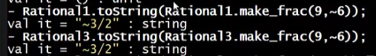

But we cannot mix and match modules:

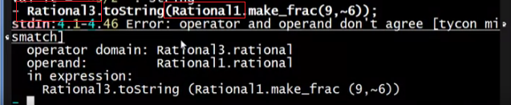

* Even if they are the same signatures
* Because definition of the rational type is INSIDE the module itself and we cannot guarantee if there are the same implementation INSIDE the module because it is hidden
  + But even implemented the same way:

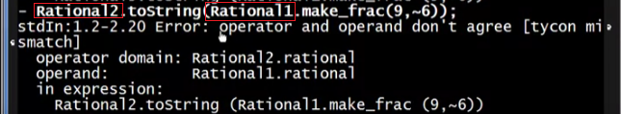

* + - It will still not type-check!!

Why it doesn’t type check?





* They are not the same types because they are in DIFFERENT modules, even if their implementations inside the module is the same

